Preparation of Full Paper for GLOBCER
Author1^{*,1}, Author2¹, Author3² ( *: corresponding author )
*e-mail address, ORCID: 0000-0000-0000-0000
¹Department name of organization1, Name of organization1, City, Country
²Department name of organization2, Name of organization2, City, Country

Abstract Abstracts must be included in the submitted papers. The abstract should be prepared in Times New Roman font with 12 pt. The abstract should be at least 250 words and should not exceed 750 words. There should no nonstandard abbreviations, acknowledgments of support, references or footnotes in the abstract. The abstract should include the purpose, method, findings and results information and information about the study. Abstract title should be written in bold and within the paragraph. "Keywords:" should be written in italic, 12 pt., with no line space after the abstract. Each word of keywords must begin with a capital letter.
Keywords: Microgrid, Wavelet, Travelling Wave

INTRODUCTION
T
HIS document is a template for Microsoft Word versions 6.0 or later. If you are reading a paper or PDF version of this document, please download the electronic file from the GLOBCER Web site at www.golbcer.org so you can use it to prepare your manuscript.
Do not change the font sizes or line spacing to squeeze more text into a limited number of pages. Use italics for emphasis; do not underline. Please observe the conference page limits.

MANUSCRIPT CONTENT

Figures and Tables
To insert images in Word, position the cursor at the insertion point and either use Insert | Picture | From File or copy the image to the Windows clipboard and then Edit | Paste Special | Picture (with “float over text” unchecked).
Large figures and tables may be placed horizontal. Place figure captions below the figures; place table titles above the tables. If your figure has two parts, include the labels “(a)” and “(b)” as part of the artwork. Please verify that the figures and tables you mention in the text actually exist. Please do not include captions as part of the figures. Do not put captions in “text boxes” linked to the figures. Do not put borders around the outside of your figures. Use the abbreviation “Fig.” even at the beginning of a sentence. Do not abbreviate “Table.” Tables are numbered with Roman numerals.
Figure axis labels are often a source of confusion. Use words rather than symbols. As an example, write the quantity “Magnetization,” or “Magnetization M,” not just “M.” Put units in parentheses. Do not label axes only with units.
As in Fig. 1, for example, write “Magnetization (A/m)” or “Magnetization (Am⁻¹),” not just “A/m.” Do not label axes with a ratio of quantities and units. For example, write “Temperature (K),” not “Temperature/K.”

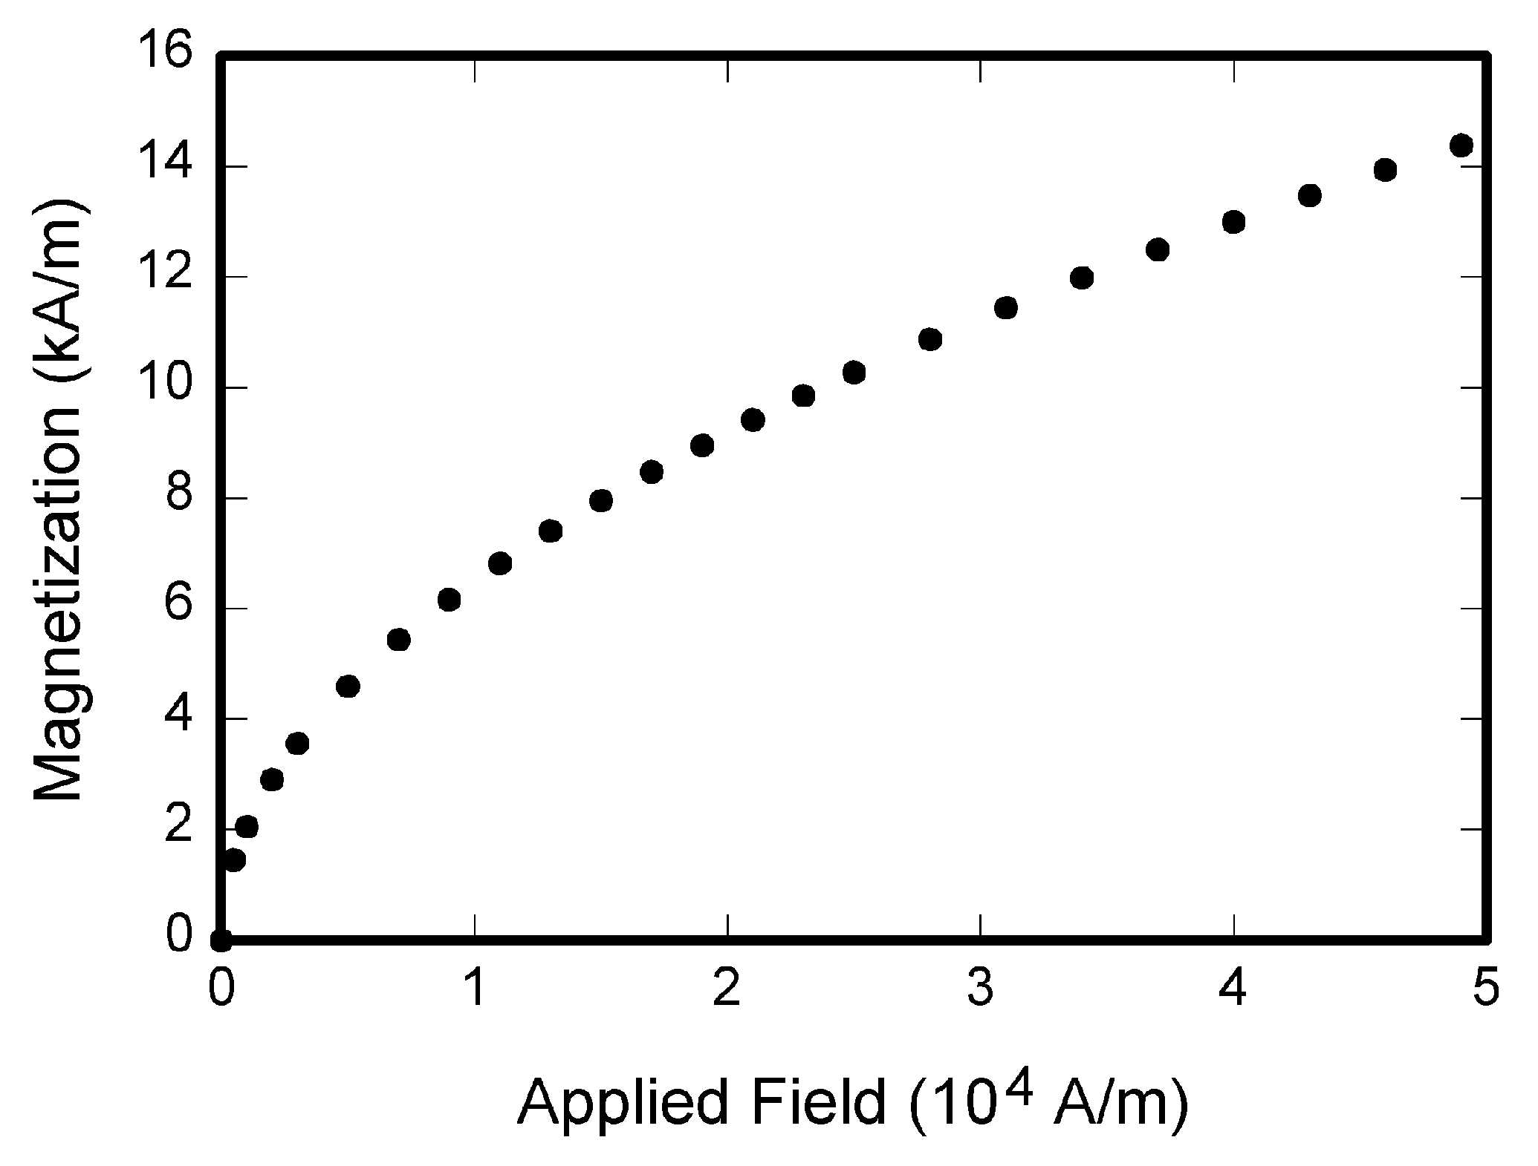
Fig. 1. Magnetization as a function of applied field. Note that “Fig.” is abbreviated. There is a period after the figure number, followed by two spaces. It is good practice to explain the significance of the figure in the caption.

Multipliers can be especially confusing. Write “Magnetization (kA/m)” or “Magnetization (10³ A/m).” Do not write “Magnetization (A/m) × 1000” because the reader would not know whether the top axis label in Fig. 1 meant 16000 A/m or 0.016 A/m. Figure labels should be legible, approximately 10 to 12 point type.

REFERENCES
This abstract may include references. Citations will be numbered consecutively within brackets [1]. The sentence punctuation follows the bracket [2]. Refer simply to the reference number, as in [3] — do not use “Ref. [3]” or “reference [3]” except at the beginning of a sentence: “Reference [3] was the first ...”
Unless there are six authors or more give all authors’ names; do not use “et al.”. Papers that have not been published, even if they have been submitted for publication, should be cited as “unpublished” [4]. Papers that have been accepted for publication should be cited as “in press” [5]. Capitalize only the first word in a paper title, except for proper nouns and element symbols.
For papers published in translation journals, please give the English citation first, followed by the original foreign-language citation [6].

Abbreviations and Acronyms
Define abbreviations and acronyms the first time they are used in the text, even after they have already been defined in the abstract. Abbreviations such as IEEE, SI, ac, and dc do not have to be defined. Abbreviations that incorporate periods should not have spaces: write “C.N.R.S.,” not “C. N. R. S.” Do not use abbreviations in the title unless they are unavoidable (for example, “GLOBCER” in the title of this article).
TABLE I
Units for Magnetic Properties
Sym | Quantity | Conversion from Gaussian and  CGS EMU to SI ª
Φ | magnetic flux | 1 Mx → 10⁻⁸ Wb = 10⁻⁸ V·s
B | magnetic flux density, magnetic induction | 1 G → 10⁻⁴ T = 10⁻⁴ Wb/m²
H | magnetic field strength | 1 Oe → 10³/(4π) A/m
m | magnetic moment | 1 erg/G = 1 emu → 10⁻³ A·m² = 10⁻³ J/T
M | magnetization | 1 erg/(G·cm³) = 1 emu/cm³ → 10³ A/m
4πM | magnetization | 1 G → 10³/(4π) A/m
σ | specific magnetization | 1 erg/(G·g) = 1 emu/g → 1 A·m²/kg
j | magnetic dipole moment | 1 erg/G = 1 emu → 4π × 10⁻¹⁰ Wb·m
J | magnetic polarization | 1 erg/(G·cm³) = 1 emu/cm³ → 4π × 10⁻⁴ T
χ, κ | susceptibility | 1 → 4π
χ_{ρ} | mass susceptibility | 1 cm³/g → 4π × 10⁻³ m³/kg
μ | permeability | 1 → 4π × 10⁻⁷ H/m = 4π × 10⁻⁷ Wb/(A·m)
μ_{r} | relative permeability | μ → μ_{r}
w, W | energy density | 1 erg/cm³ → 10⁻¹ J/m³
N, D | demagnetizing factor | 1 → 1/(4π)
Vertical lines are optional in tables. Statements that serve as captions for the entire table do not need footnote letters. Gaussian units are the same as cgs emu for magnetostatics; Mx = maxwell, G = gauss, Oe = oersted; Wb = weber, V = volt, s = second, T = tesla, m = meter, A = ampere, J = joule, kg = kilogram, H = henry.

Equations
Number equations consecutively with equation numbers in parentheses flush with the right margin, as in (1). First use the equation editor to create the equation. Then select the “Equation” markup style. Press the tab key and write the equation number in parentheses. To make your equations more compact, you may use the solidus ( / ), the exp function, or appropriate exponents. Use parentheses to avoid ambiguities in denominators. Punctuate equations when they are part of a sentence, as in

$⋅ \int_{ 0}^{ ∞{{{{{{∫_{j}}_{i}}^{-1}}_{1}}_{2}}_{0}}_{i}}{ exp}$$\int{\left(\frac{-b±\sqrt{b^{2}-4ac}}{2a}\right)}e^{-iω(t)}\frac{Δy}{Δx}\frac{∂y}{∂x}\sum{\frac{π}{2}}$ (1)

Be sure that the symbols in your equation have been defined before the equation appears or immediately following. Italicize symbols (T might refer to temperature, but T is the unit tesla). Refer to “(1),” not “Eq. (1)” or “equation (1),” except at the beginning of a sentence: “Equation (1) is ... .”

RECOMMENDATIONS ABOUT PAPER FORMAT
Use one space after periods and colons. Hyphenate complex modifiers: “zero-field-cooled magnetization.” Avoid dangling participles, such as, “Using (1), the potential was calculated.” [It is not clear who or what used (1).] Write instead, “The potential was calculated by using (1),” or “Using (1), we calculated the potential.”
Use a zero before decimal points: “0.25,” not “.25.” Use “cm³,” not “cc.” Indicate sample dimensions as “0.1 cm × 0.2 cm,” not “0.1 × 0.2 cm².” The abbreviation for “seconds” is “s,” not “sec.” Do not mix complete spellings and abbreviations of units: use “Wb/m²” or “webers per square meter,” not “webers/m².” When expressing a range of values, write “7 to 9” or “7-9,” not “7~9.”
A parenthetical statement at the end of a sentence is punctuated outside of the closing parenthesis (like this). (A parenthetical sentence is punctuated within the parentheses.) In American English, periods and commas are within quotation marks, like “this period.” Other punctuation is “outside”! Avoid contractions; for example, write “do not” instead of “don’t.” The serial comma is preferred: “A, B, and C” instead of “A, B and C.”
If you wish, you may write in the first person singular or plural and use the active voice (“I observed that ...” or “We observed that ...” instead of “It was observed that ...”). Remember to check spelling. If your native language is not English, please get a native English-speaking colleague to carefully proofread your paper.

CONCLUSION
Please include a brief summary of the possible clinical implications of your work in the conclusion section. Although a conclusion may review the main points of the paper, do not replicate the abstract as the conclusion. Consider elaborating on the translational importance of the work or suggest applications and extensions.

APPENDIX
Appendixes, if needed, appear before the acknowledgment.

ACKNOWLEDGMENT
The preferred spelling of the word “acknowledgment” in American English is without an “e” after the “g.” Use the singular heading even if you have many acknowledgments. Avoid expressions such as “One of us (S.B.A.) would like to thank ... .” Instead, write “F. A. Author thanks ... .” Sponsor and financial support acknowledgments are placed in the unnumbered footnote on the first page, not here.

REFERENCES
- G. Eason, B. Noble, and I.N. Sneddon, “On certain integrals of Lipschitz-Hankel type involving products of Bessel functions,” Phil. Trans. Roy. Soc. London, vol. A247, pp. 529-551, April 1955. (references)
- J. Clerk Maxwell, A Treatise on Electricity and Magnetism, 3rd ed., vol. 2. Oxford: Clarendon, 1892, pp.68-73.
- I.S. Jacobs and C.P. Bean, “Fine particles, thin films and exchange anisotropy,” in Magnetism, vol. III, G.T. Rado and H. Suhl, Eds. New York: Academic, 1963, pp. 271-350.
- K. Elissa, “Title of paper if known,” unpublished.
- R. Nicole, “Title of paper with only first word capitalized,” J. Name Stand. Abbrev., in press.
- Y. Yorozu, M. Hirano, K. Oka, and Y. Tagawa, “Electron spectroscopy studies on magneto ptical media and plastic substrate interface,” IEEE Transl. J. Magn. Japan, vol. 2, pp. 740-741, August 1987 [Digests 9th Annual Conf. Magnetics Japan, p. 301, 1982].
- M. Young, The Technical Writer’s Handbook. Mill Valley, CA: University Science, 1989.

